Title:
This project is about programming a Deep Neural Network using python numpy

Progress:

1. Processing Data
In this project, I use Mnist datasets from keras for just for testing if the NN is working or not. This is a dataset of 60,000 28x28 grayscale images of the 10 digits, along with a test set of 10,000 images.
Fist load the dataset and some necessary libraries.
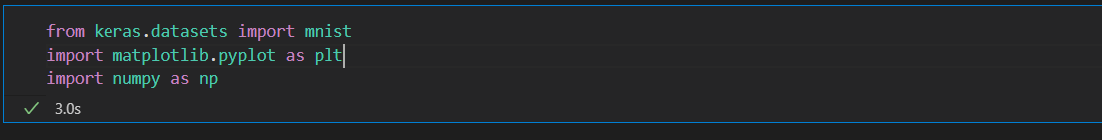
These code below is how I processing the input data and label data

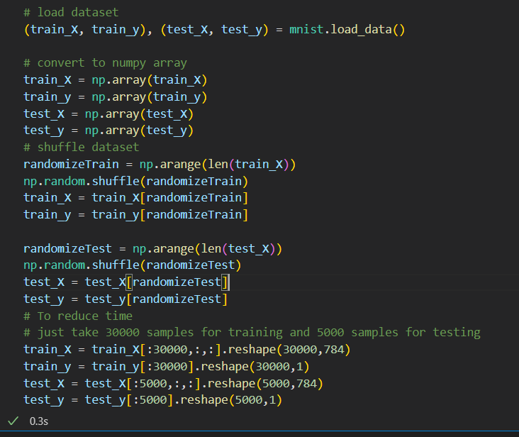

After shuffle the data, I just take 30000 samples for training and 5000 samples for testing.
The input for my Neural Net is a 2D matrix so I flatten 28x28 image to an 1D array with 784 elements.
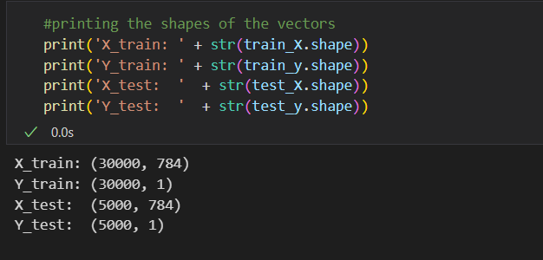

To enhance the performance and decrease the training time, I rescale the input Image using MeanNormalize function below to ensure the input value will from [-0.5;0.5]. The input labels of my NN is an 1D matrix with the elements is 0 or 1, by using function labelling, I can create an matrix as I want ( Example: if the labels is 8, the labels after applied labelling function is [0,0,0,0,0,0,0,0,1,0] )

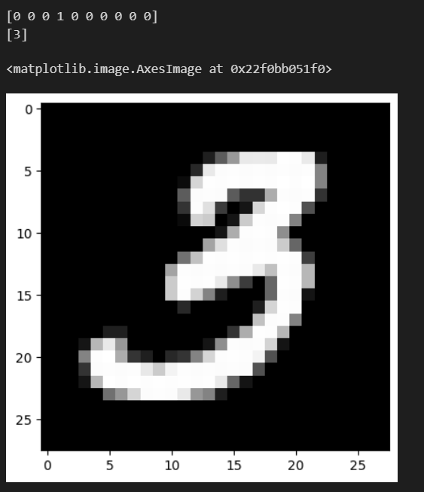
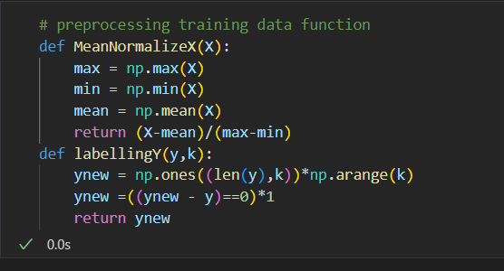

Now the data is ready for training:

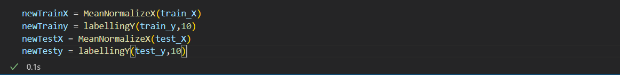

2. Neural Network:
I create an class name NeuralNet with the input componets include Input data, label data, learning rate, list of hidden layers.
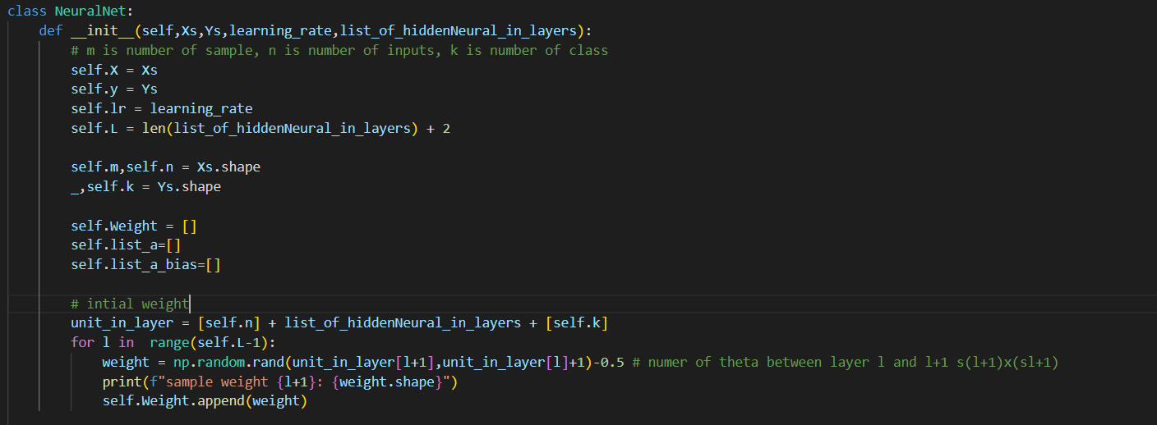

With S_{l} is the number of node in layer l and S_{l+1} is number of node in layer l+1. The Weight will be a 2D matrix
Here is how I declare my neural net:
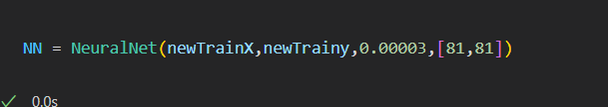
Before digging deaper in how my NN work, here I create some function to make my coding easier.
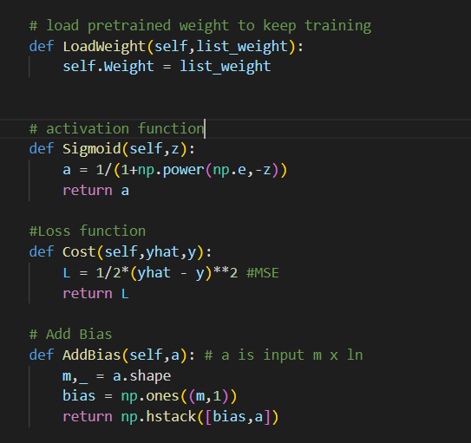

Firstly, I create a function for forward:
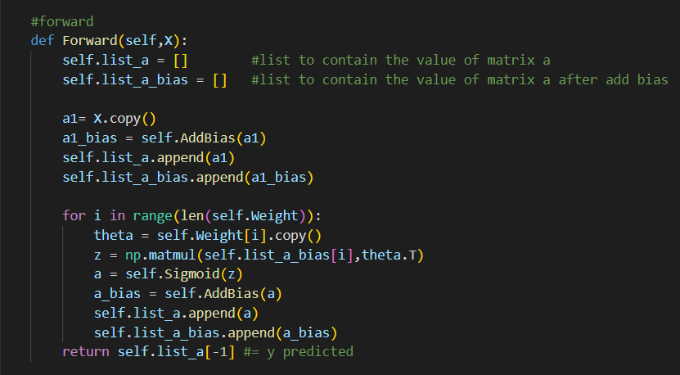
I saved the value of each node in list_a and value of node with bias in list_a_bias, these will be helpful for calculate backpropagation.
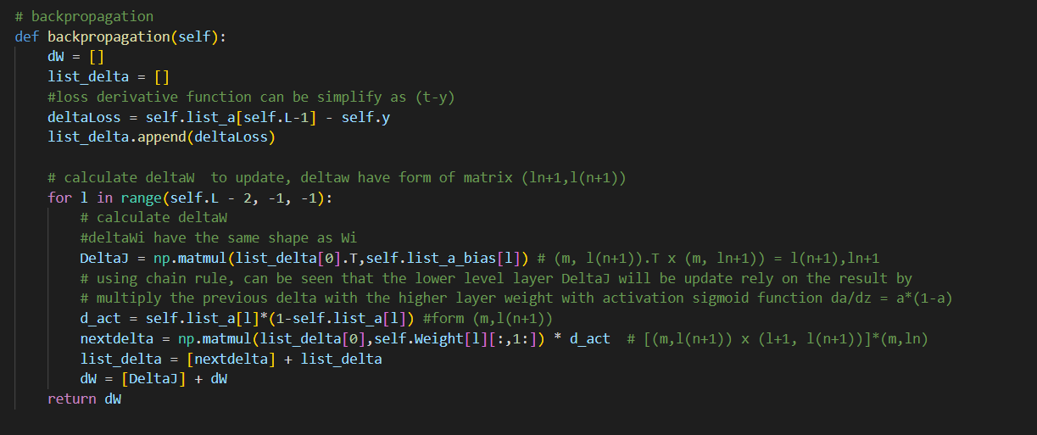

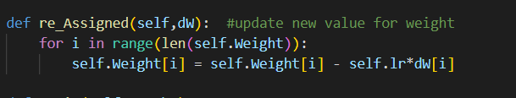
Then create an function for training
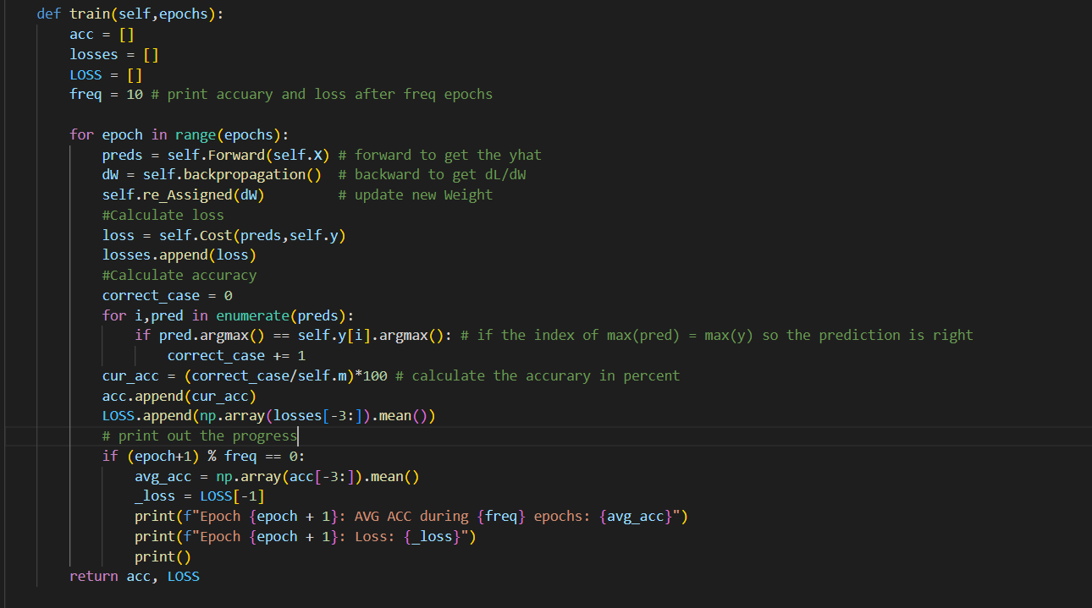
Also to let the estimation progressing become more clearlier, I create 3 more function

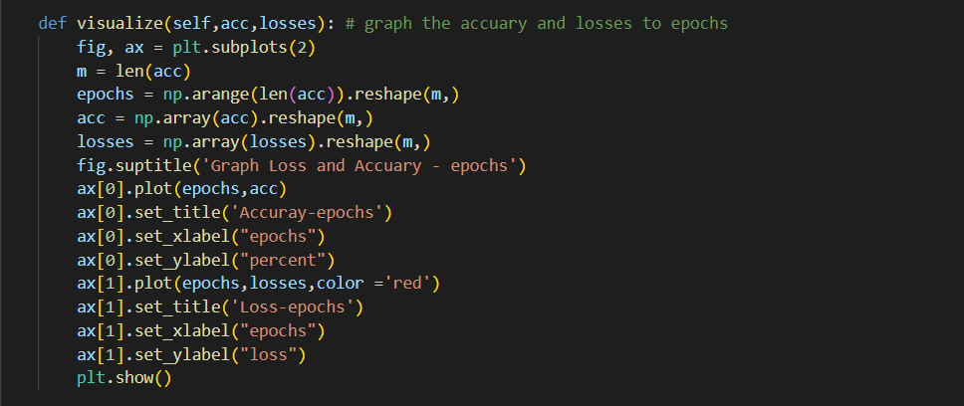

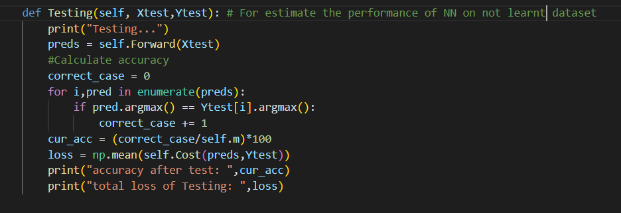

3.Training and Result
For the training, first import the NeuralNet class from myNeuralNetwork. Then I declare my Neural Net as NN with 2 hidden layers each hidden layer has 81 node and training with learning rate 0.00003:

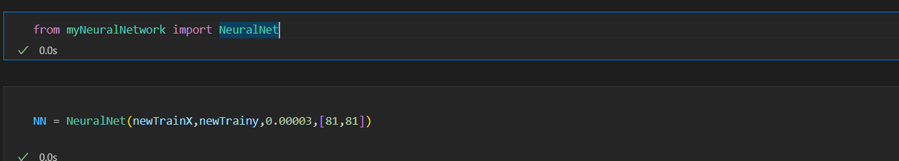
After train 500 epochs, the total time it takes is less than 7,5 minutes, means that each epoch takes about 0.9 seconds.

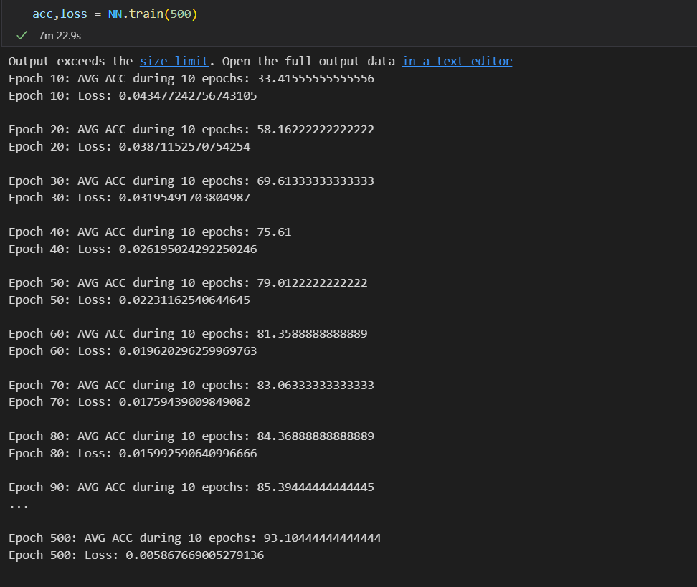
Visualize:
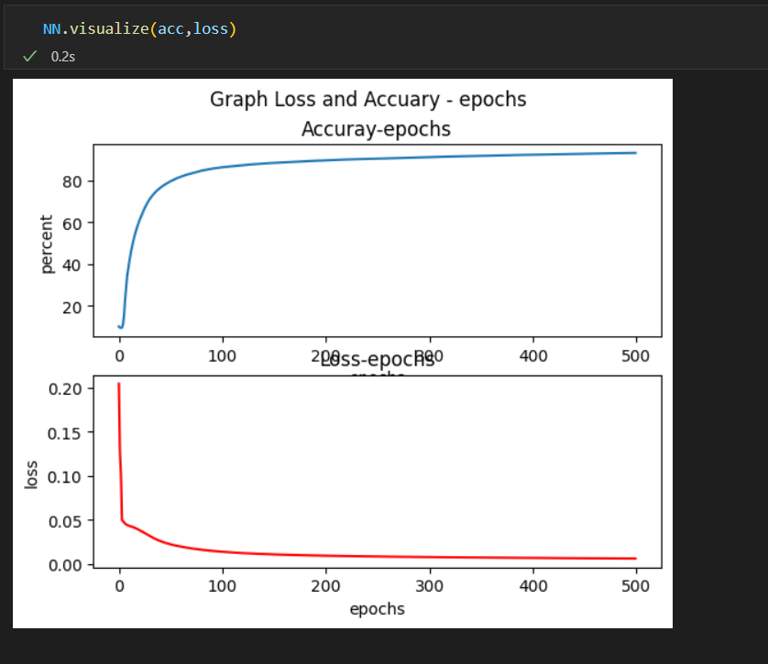
But the testing performance is so bad
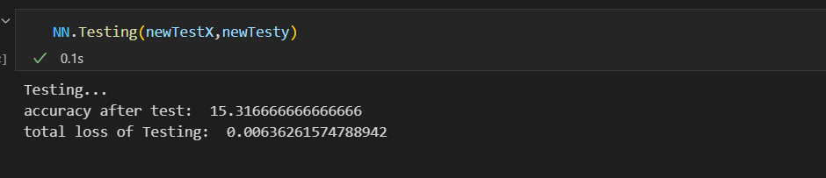
The NN seams just know what it learnt

4. Reference
The list of video of Andrew Ng https://www.youtube.com/watch?v=CS4cs9xVecg&list=PLkDaE6sCZn6Ec-XTbcX1uRg2_u4xOEky0

